|  |
| --- |
| Circle Language Spec: Commands |

## Commands Anywhere

Commands are executable objects that can freely move around. You have to start thinking of an executable object more like an object, that just happens to be executable. You are going to have to see an execution much, much more like an executable object that can be situated anywhere and referenced from anywhere. You can put the executable object inside another object. You can reference an executable object. Yes, you can put an executable object inside a command definition. But you can also put an executable object inside a class.

You can run an execution inside an object, sort of like having an execution run inside a specific folder. You can also run the execution inside your user object and sort of take it along with you, whereever you go into the digital world. You can also run an execution globally on a site.

Executions can also be placed in a list. No problem. You can run each item in the list individually.

### Diagram Notation

You can put the executable object inside another object:



You can reference an executable object:

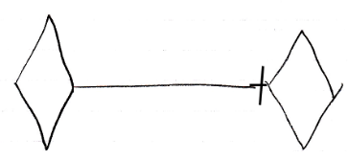

Yes, you can put an executable object inside a command definition:



But you can also put an executable object inside a class:



You can run an execution inside an object, sort of like having an execution run inside a specific folder:

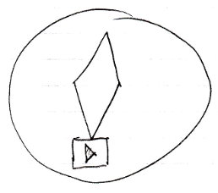

You can also run the execution inside your user object and sort of take it along with you, whereever you go into the digital world.

You can also run an execution globally on a site.

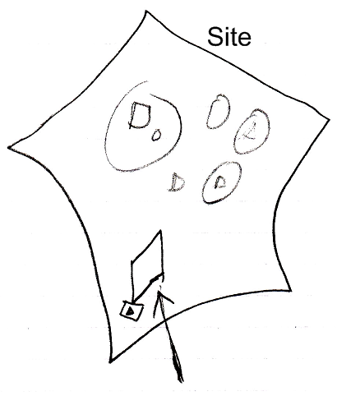

Executions can also be placed in a list. No problem. You can run each item in the list individually.

